Table of Contents

1. Purpose 2

1.1. Intended Audience 2

1.2. Intended Use 2

1.3. Scope 2

1.4. Definitions and Acronyms 2

2. Overall System Description 3

2.1. Use Case Diagrams 3

2.2. System Architecture 4

2.3. Functional Requirements 5

2.3.1. Function xxxx 5

2.3.2. Function yyyy 6

2.3.3. Function zzzz 6

3.1. Non-Functional Requirements 7

3.1.1. Non-Functional Requirement xxxx 7

4. Software Architecture 8

4.1. Static Software Architecture 8

# Purpose

## Intended Audience

This SRS document describes the System Requirements and Software Design for an IoT Coffee maker and the target audience are System and Software Engineers working on the development of this project.

## Intended Use

The SRS defines the overall System Architecture and Requirements as well as the Software Architecture and Design. This document is also contains the definition of the System Requirements which shall be used as the input for System Test cases and Software Unit Test cases.

## Scope

## Definitions and Acronyms

|  |  |
| --- | --- |
| **Acronym** | **Description** |
| IR | Infra Red |
| LED | Light Emitting Diode |
| NFC | Near Field Communication |
| SW | Software |
| HW | Hardware |

# Overall System Description

## Use Case Diagrams

Add Use Case diagrams here ..

RFID unlock door

Home Automation System

## System Architecture



DC Motor

Servo Motor

LED

Humidity and Temperature Sensor

DHT11

LCD

I2C

**Raspberry Pi Development Board**

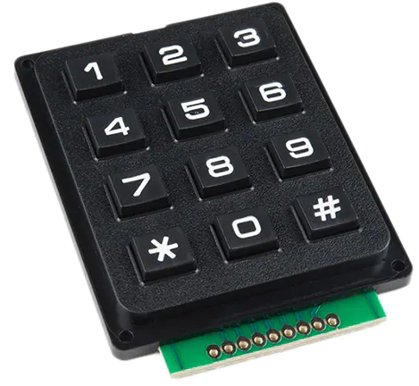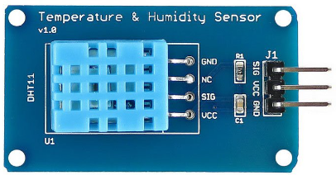

keypad

lock

Ceiling fan

Lights in all room

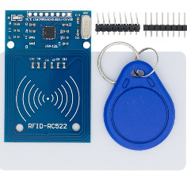

3 x 4 keypad

keycard reader

RFID-RC522

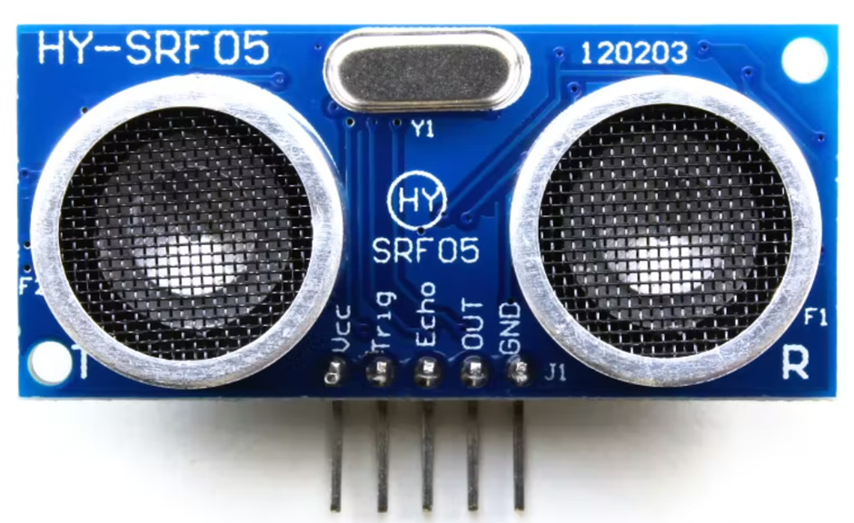

Close/open door status sensor

HY-SRF05

## Functional Requirements

### Start up and main menu

Add short description here …

|  |  |
| --- | --- |
| **REQ_ID** | **Requirement** |
| REQ-01 | When the device is powered on, the main menu (LCD) will display  Line 1= “Press keycard”  Line2= “or password: ” |

### Unlock Door

NFC unlock

|  |  |
| --- | --- |
| **REQ_ID** | **Requirement** |
| REQ-02 | NFC checks for keycard |
| REQ-03 | Check if key card matches the ID(s) in the database |
| REQ-04 | If the key card matches with the ID. |
| REQ-05 | If REQ-04 is met unlock the door indicated by the servo motor. Line 1=”Access granted” for 1 second and goes and display REQ-1 |
| REQ-06 | If REQ-04 is not met display on LCD Line 1 =“Access denied”. for 1 second and goes and display REQ-1 |

### Forced intrusion

Add short description here …

|  |  |
| --- | --- |
| **REQ_ID** | **Requirement** |
| REQ-07 | Check whether the door is in a locked or unlocked state via the switch. |
| REQ-08 | Check if the door is in a locked state via switch and detected to be in an open state via ultra-sonic ranger. |
| REQ-09 | If the above REQ is met it is considered to be a forced entry and a buzzer will ring. |

### Unlock door

1. Keypad

|  |  |
| --- | --- |
| **REQ_ID** | **Requirement** |
| REQ-11 | Keypad checks for input and store it into an array of 4 |
| REQ-12 | The LCD will display x amount of stars(*) where x is how long the array is. |
| REQ-13 | Check if there is 4 value in the array |
| REQ-14 | If REQ 13 is met check if the array values matches the following values  1234  2345  3456  4567  The servo motor turns to 0 degrees.  LCD will display Line 1= “Access granted”. |
| REQ-15 | If it the array reaches 4 and the password is incorrect it will the input stored into the array restarted and LCD displays Line 1=“Incorrect password” for 1 second and goes back to displaying REQ-1 |

### Remote access

1. Add short description here …

|  |  |
| --- | --- |
| **REQ_ID** | **Requirement** |
| REQ-16 | The user shall be able to login to the IP address of the IoT Door to view a web page |
| REQ-17 | The internal Web Server on the IoT Door shall allow the user to monitor the following,     * Moisture and temperature of room (DHT11) * Front door open/close status (switch) * Unlock/Lock door (servo motor) 0 degree= unlocked 90 degree = locked |
| REQ-18 | The internal Web Server on the IoT Coffee Maker shall allow the user to control the following,     * Ceiling Fans (DC motor) * Lights in all rooms (LED) |

# Software Architecture

## Static Software Architecture

The Software Architecture defines the various Software Components that are developed to realize the implementation of the system requirements.

**Hardware Abstraction Layer (HAL)**

**Application Layer**

**lcd**

**Sonic**

**Temp_humidty**

**Moisture_sensor**

**Dht11**

**Dc_motor**

**Input_switch**

**servo**

**rfid**

**led**

**buzzer**

**USonic**

Raspberry_pi_webserver

main

keypad

Intruder_ detected

RFID